Initial steps we perform to get the 85 % accuracy:
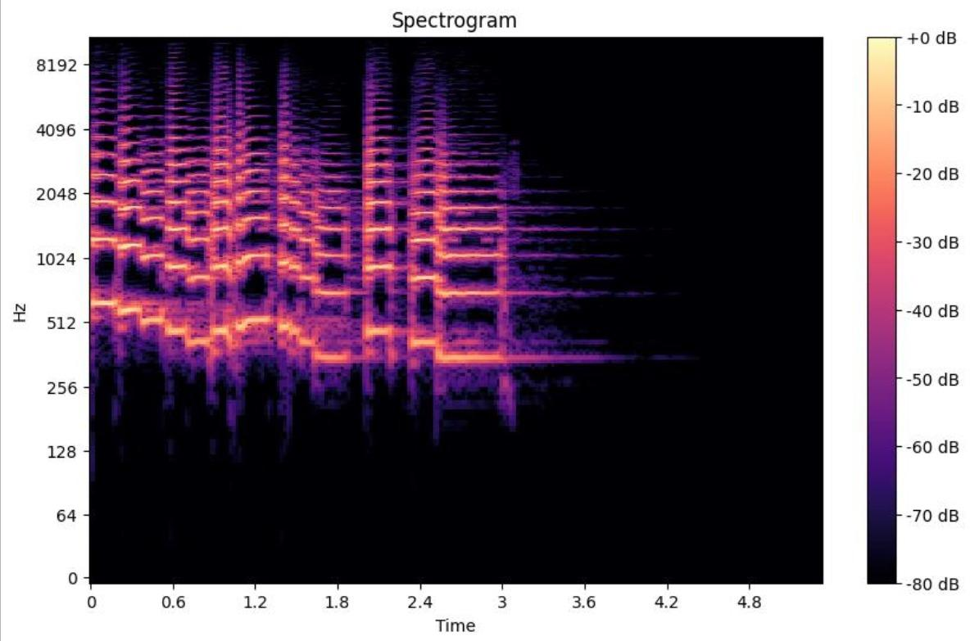
first we trained the model on spectogram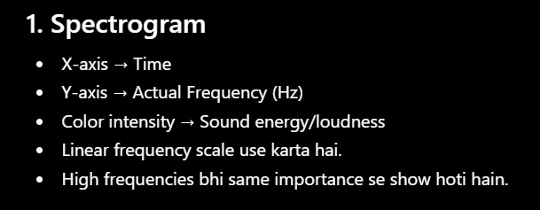

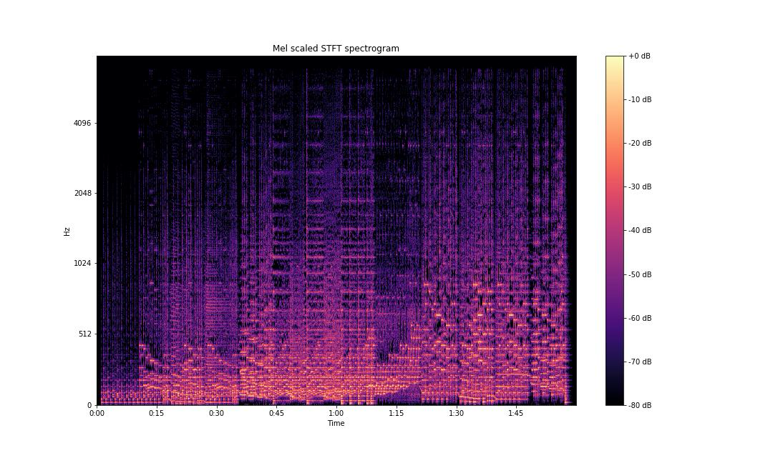
then we trained using mel spectogram , we got better results

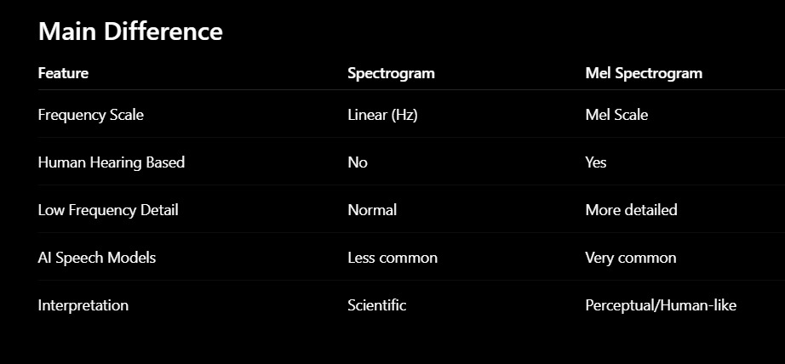

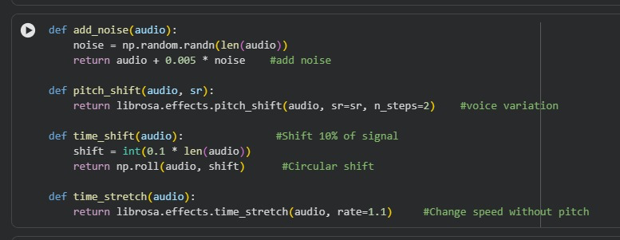

then we did data augmentation

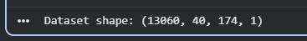

total dataset size

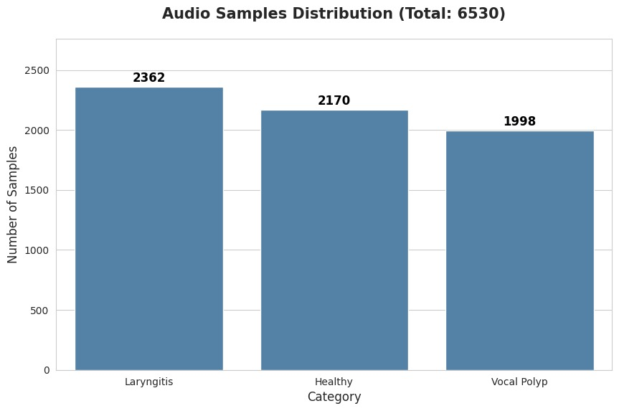
initial data
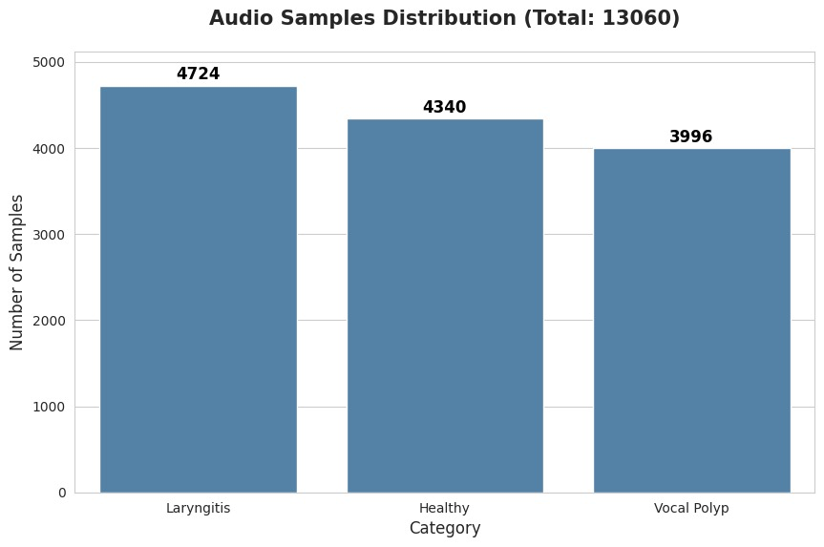
after augmentatin

train test split

Applied SMOTE on training set

and got accuracy of 85 percent

and this is how we came to our final model

melspectogram + data augmentation + SMOTE

